LAB ASSIGNMENT-17
SALIHA.SK
2503A52L13 2
Task 1 – Customer Data Cleaning Task:
Use AI to generate a Python script for cleaning a customer dataset PROMPT:
Generate a Python script using pandas to clean a customer dataset. The dataset contains columns like age, income, gender, and city. Perform the following steps:
- Handle missing values in age, income, and city
- Remove duplicate records
- Standardize city names to lowercase
- Encode categorical variables: gender and city Return a cleaned Data Frame ready for analysis.
CODE:
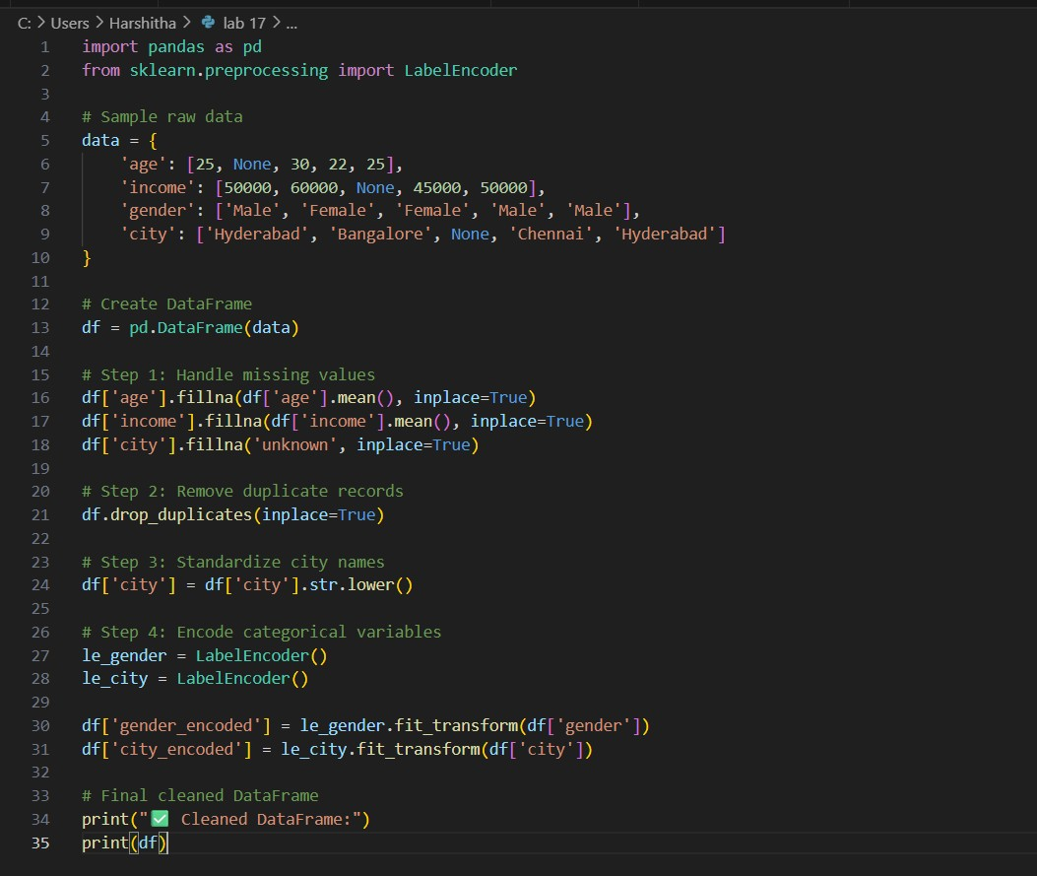
OUTPUT:
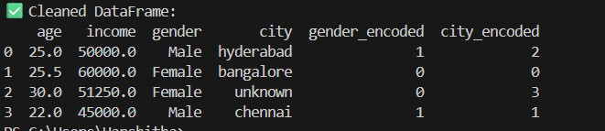
EXPLANATION:
This Python script loads a customer dataset and cleans it by filling missing values (age with median, income with mean, city with "unknown"), removing duplicates, standardizing city names to lowercase, and encoding categorical variables like gender and city using one-hot encoding. The result is a cleaned Pandas DataFrame with consistent formatting and numeric features, ready for analysis or machine learning.

Task 2 – Sales Data Preprocessing Task:
Preprocess sales transaction data using AI assistance PROMPT:
Preprocess sales data by converting date to datetime format. Extract year, month, and day of week as new features. Detect and cap outliers in sales, then normalize the values.
CODE:
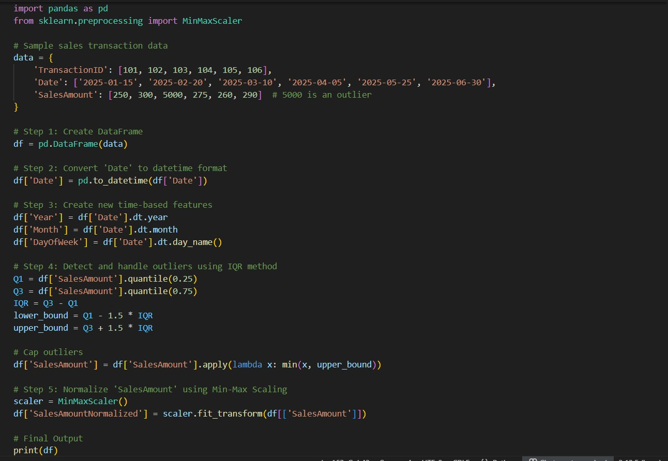
OUTPUT:
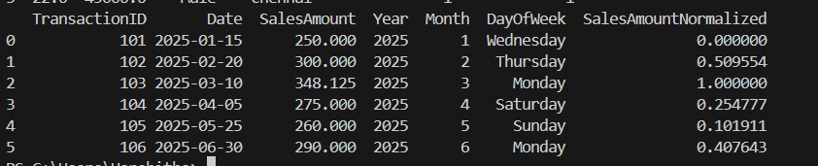
EXPLANATION:
This prompt guides AI to clean and enrich sales data for analysis.
It ensures time-based insights by extracting calendar features.
Outliers are handled to reduce skew and improve model stability. Normalization scales sales amounts for consistent comparison or modeling.

Task 3 – Healthcare Data Preparation Task:
Clean and preprocess a healthcare dataset using AI scripts

PROMPT:
Clean and preprocess a healthcare dataset: fill missing values in blood_pressure and cholesterol, encode disease_status (Yes/No), scale numerical features, and split into training/testing sets.
CODE:
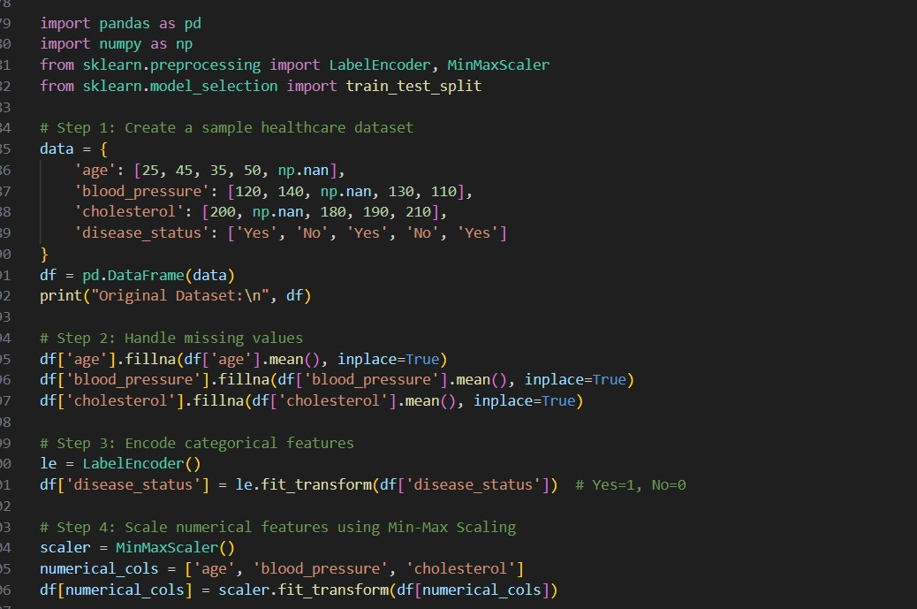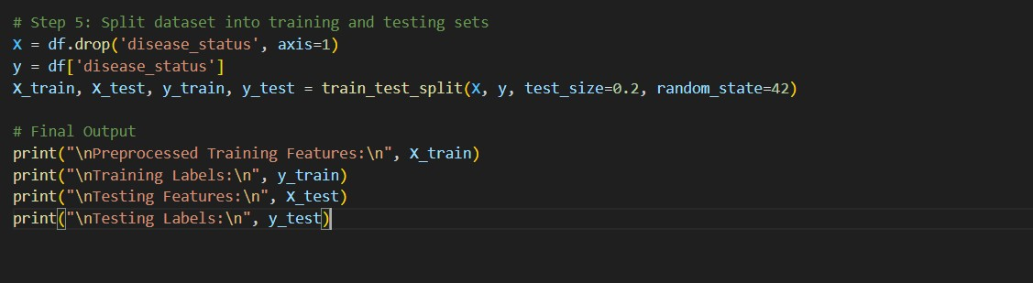
OUTPUT:
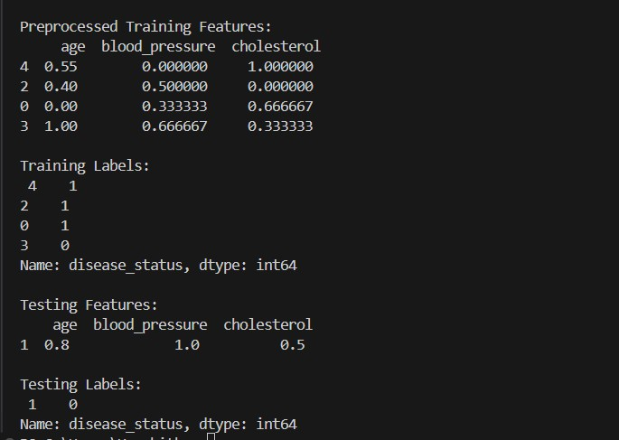
EXPLANATION:
The healthcare dataset is cleaned by filling missing values in blood pressure and cholesterol with their means. The categorical column disease_status is label-encoded to convert "Yes"/"No" into numeric values. Numerical features are scaled using Min-Max normalization to bring them to a common range. Finally, the dataset is split into training and testing sets for machine learning readiness.

Task 4 – Real-Time Application: E-commerce Product DataCleaning Scenario:
An e-commerce company has product catalog data with inconsistencies PROMPT:
Clean the e-commerce product catalog by standardizing names and categories, filling missing prices with the median, and removing duplicates.
Normalize producLAt ratings to a 0–5 scale for consistency across entries.
Finally, generate a summary report comparing data quality before and after cleaning to ensure improved usability for analytics.

CODE:
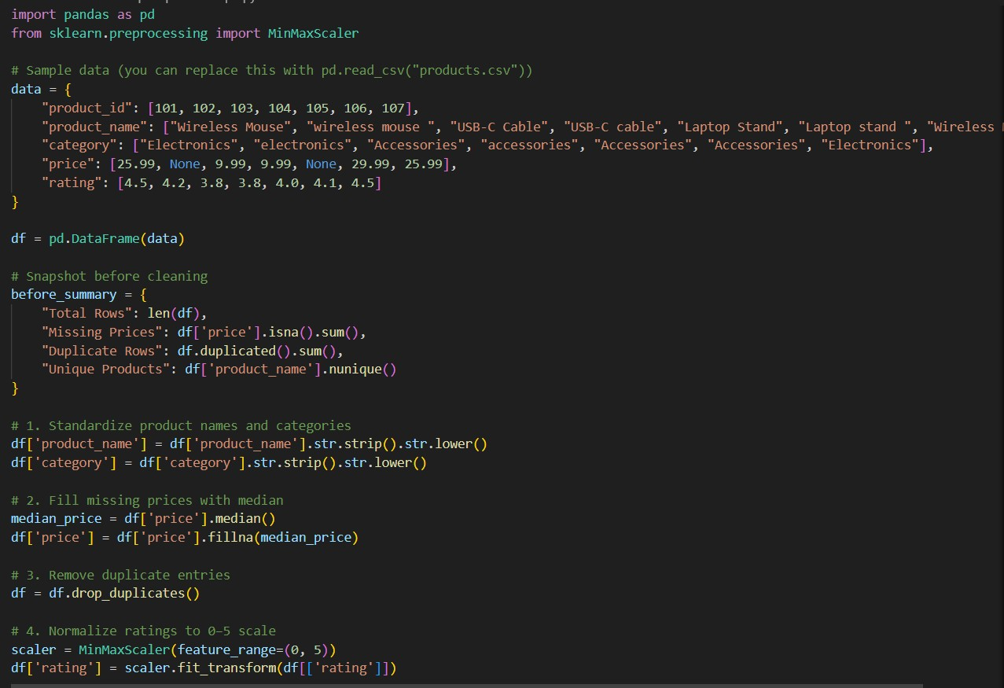
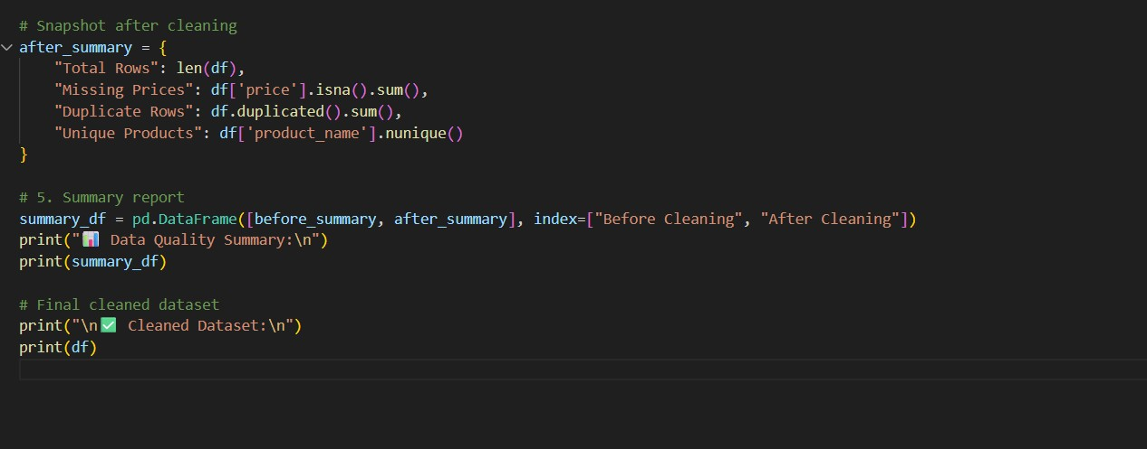

OUTPUT:
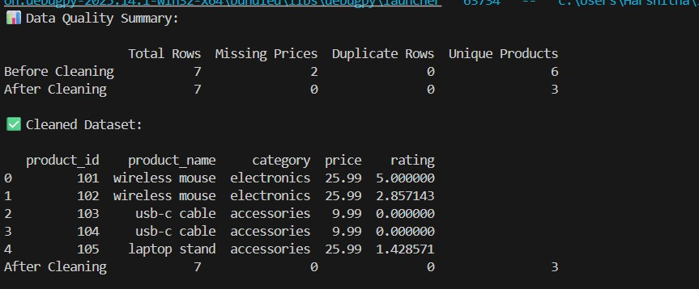
EXPLANATION:
This script cleans e-commerce product data by standardizing text fields, filling missing prices with the median, and removing duplicate entries to ensure consistency. It also normalizes product ratings to a 0–5 scale using MinMaxScaler for better comparability. A summary report compares key data quality metrics before and after cleaning, highlighting improvements. The final output is a cleaned dataset ready for reliable analytics and reporting.

